* **Activity 9:**

Retrieving Data Using LEFT OUTER JOIN

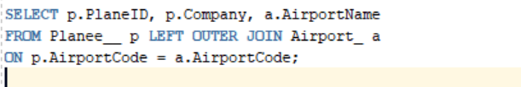

OUTPUT:

